package application;  
import javafx.animation.RotateTransition;  
import javafx.application.Application;  
  
import javafx.scene.Group;  
import javafx.scene.Scene;  
import javafx.scene.paint.Color;  
import javafx.scene.shape.Rectangle;  
import javafx.scene.transform.Rotate;  
import javafx.stage.Stage;  
import javafx.util.Duration;  
public class Video extends Application{  
  
 @Override  
 public void start(Stage primaryStage) throws Exception {  
 // *TODO Auto-generated method stub* //Creating Rectangle  
 Rectangle rect = new Rectangle(200,100,200,200);  
 rect.setFill(Color.*LIMEGREEN*);  
 rect.setStroke(Color.*HOTPINK*);  
 rect.setStrokeWidth(5);  
  
 //Instantiating RotateTransition class  
 RotateTransition rotate = new RotateTransition();  
  
 //Setting Axis of rotation  
 rotate.setAxis(Rotate.*Z_AXIS*);  
  
 // setting the angle of rotation  
 rotate.setByAngle(360);  
  
 //setting cycle count of the rotation  
 rotate.setCycleCount(500);  
  
 //Setting duration of the transition  
 rotate.setDuration(Duration.*millis*(1000));  
  
 //the transition will be auto reversed by setting this to true  
 rotate.setAutoReverse(true);  
  
 //setting Rectangle as the node onto which the  
// transition will be applied  
 rotate.setNode(rect);  
  
 //playing the transition  
 rotate.play();  
  
 //Configuring Group and Scene  
 Group root = new Group();  
 root.getChildren().add(rect);  
 Scene scene = new Scene(root,600,400,Color.*BLACK*);  
 primaryStage.setScene(scene);  
 primaryStage.setTitle("Rotate Transition example");  
 primaryStage.show();  
  
 }  
 public static void main(String[] args) {  
 *launch*(args);  
 }  
  
}

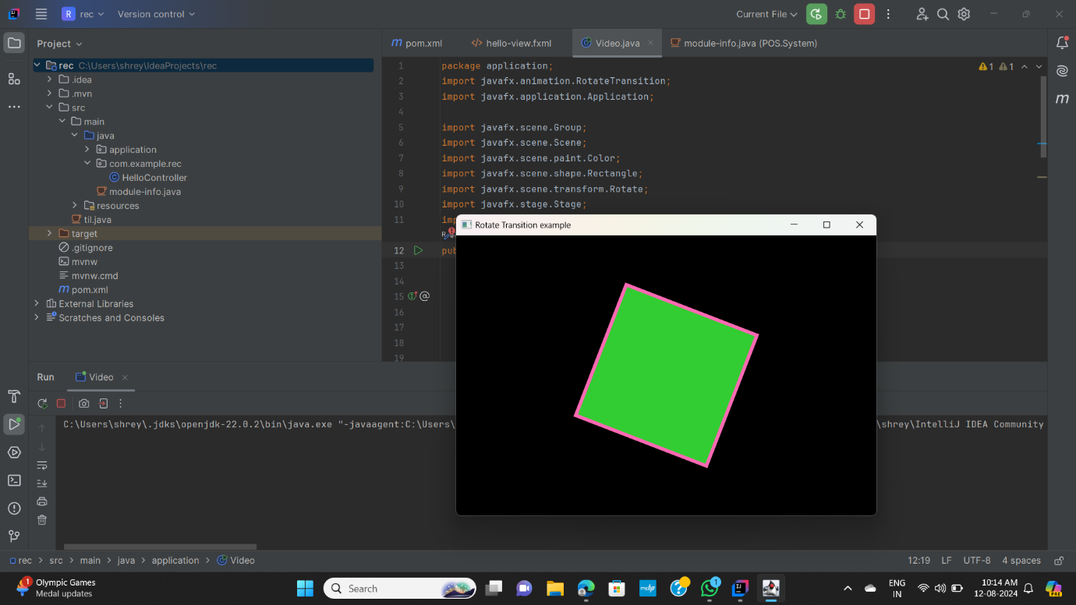

package application;  
import javafx.animation.StrokeTransition;  
import javafx.application.Application;  
  
import javafx.scene.Group;  
import javafx.scene.Scene;  
import javafx.scene.paint.Color;  
import javafx.scene.shape.Circle;  
  
import javafx.stage.Stage;  
import javafx.util.Duration;  
public class Video extends Application{  
  
 @Override  
 public void start(Stage primaryStage) throws Exception {  
  
 Circle c = new Circle(250,150,80);  
 c.setFill(Color.*LIMEGREEN*);  
 c.setStroke(Color.*HOTPINK*);  
 c.setStrokeWidth(10);  
  
  
 StrokeTransition st = new StrokeTransition();  
  
  
 st.setFromValue(Color.*BLUE*);  
 st.setToValue(Color.*RED*);  
  
  
 st.setCycleCount(500);  
  
  
 st.setDuration(Duration.*millis*(1000));  
  
  
 st.setAutoReverse(true);  
  
  
 st.setShape(c);  
  
  
 st.play();  
  
  
 Group root = new Group();  
 root.getChildren().addAll(c);  
 Scene scene = new Scene(root,500,400,Color.*BLACK*);  
 primaryStage.setScene(scene);  
 primaryStage.setTitle("Translate Transition example");  
 primaryStage.show();  
  
 }  
 public static void main(String[] args) {  
 *launch*(args);  
 }  
  
}

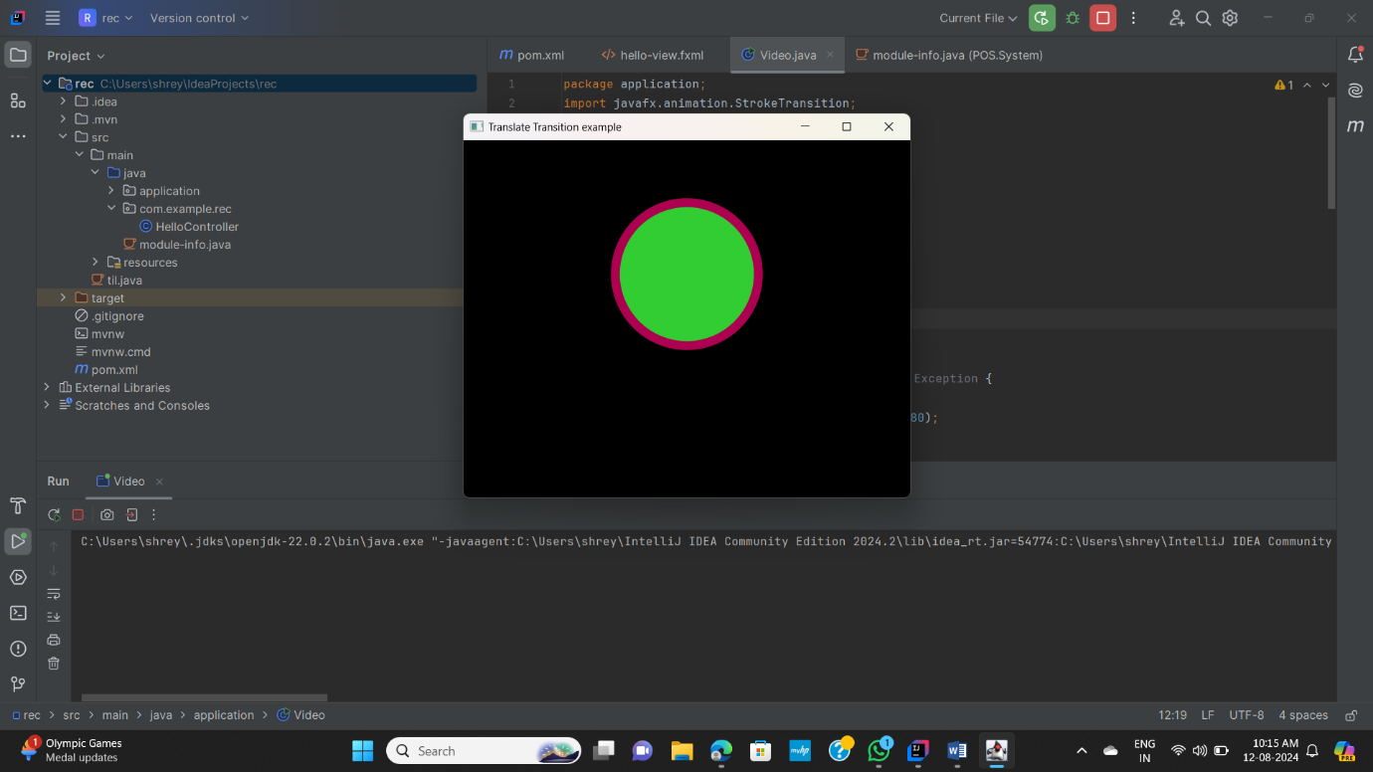

package application;  
import javafx.animation.FillTransition;  
import javafx.application.Application;  
  
import javafx.scene.Group;  
import javafx.scene.Scene;  
import javafx.scene.paint.Color;  
import javafx.scene.shape.Circle;  
  
import javafx.stage.Stage;  
import javafx.util.Duration;  
public class Video extends Application{  
  
 @Override  
 public void start(Stage primaryStage) throws Exception {  
  
 Circle c = new Circle(250,150,80);  
 c.setFill(Color.*LIMEGREEN*);  
 c.setStroke(Color.*HOTPINK*);  
 c.setStrokeWidth(10);  
  
  
 FillTransition ft = new FillTransition();  
  
  
 ft.setFromValue(Color.*BLUE*);  
 ft.setToValue(Color.*RED*);  
  
 ft.setCycleCount(500);  
  
  
 ft.setDuration(Duration.*millis*(1000));  
  
  
 ft.setAutoReverse(true);  
  
  
 ft.setShape(c);  
  
  
 ft.play();  
  
  
 Group root = new Group();  
 root.getChildren().add(c);  
 Scene scene = new Scene(root,500,400,Color.*BLACK*);  
 primaryStage.setScene(scene);  
 primaryStage.setTitle("Translate Transition example");  
 primaryStage.show();  
  
 }  
 public static void main(String[] args) {  
 *launch*(args);  
 }  
  
}

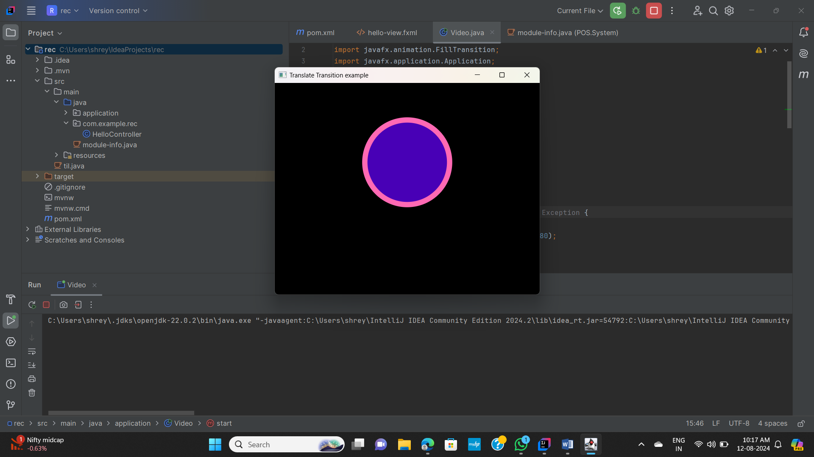

package application;  
import javafx.animation.FadeTransition;  
import javafx.application.Application;  
  
import javafx.scene.Group;  
import javafx.scene.Scene;  
import javafx.scene.paint.Color;  
import javafx.scene.shape.Circle;  
  
import javafx.stage.Stage;  
import javafx.util.Duration;  
public class Video extends Application{  
  
 @Override  
 public void start(Stage primaryStage) throws Exception {  
  
 Circle c = new Circle(250,150,80);  
 c.setFill(Color.*LIMEGREEN*);  
 c.setStroke(Color.*HOTPINK*);  
 c.setStrokeWidth(5);  
  
  
 FadeTransition ft = new FadeTransition();  
  
  
 ft.setFromValue(1.0);  
 ft.setToValue(0.1);  
  
  
  
 ft.setCycleCount(500);  
  
  
 ft.setDuration(Duration.*millis*(1000));  
  
  
 ft.setAutoReverse(true);  
  
 ft.setNode(c);  
  
  
 ft.play();  
  
  
 Group root = new Group();  
 root.getChildren().add(c);  
 Scene scene = new Scene(root,500,400,Color.*BLACK*);  
 primaryStage.setScene(scene);  
 primaryStage.setTitle("Translate Transition example");  
 primaryStage.show();  
  
 }  
 public static void main(String[] args) {  
 *launch*(args);  
 }  
  
}

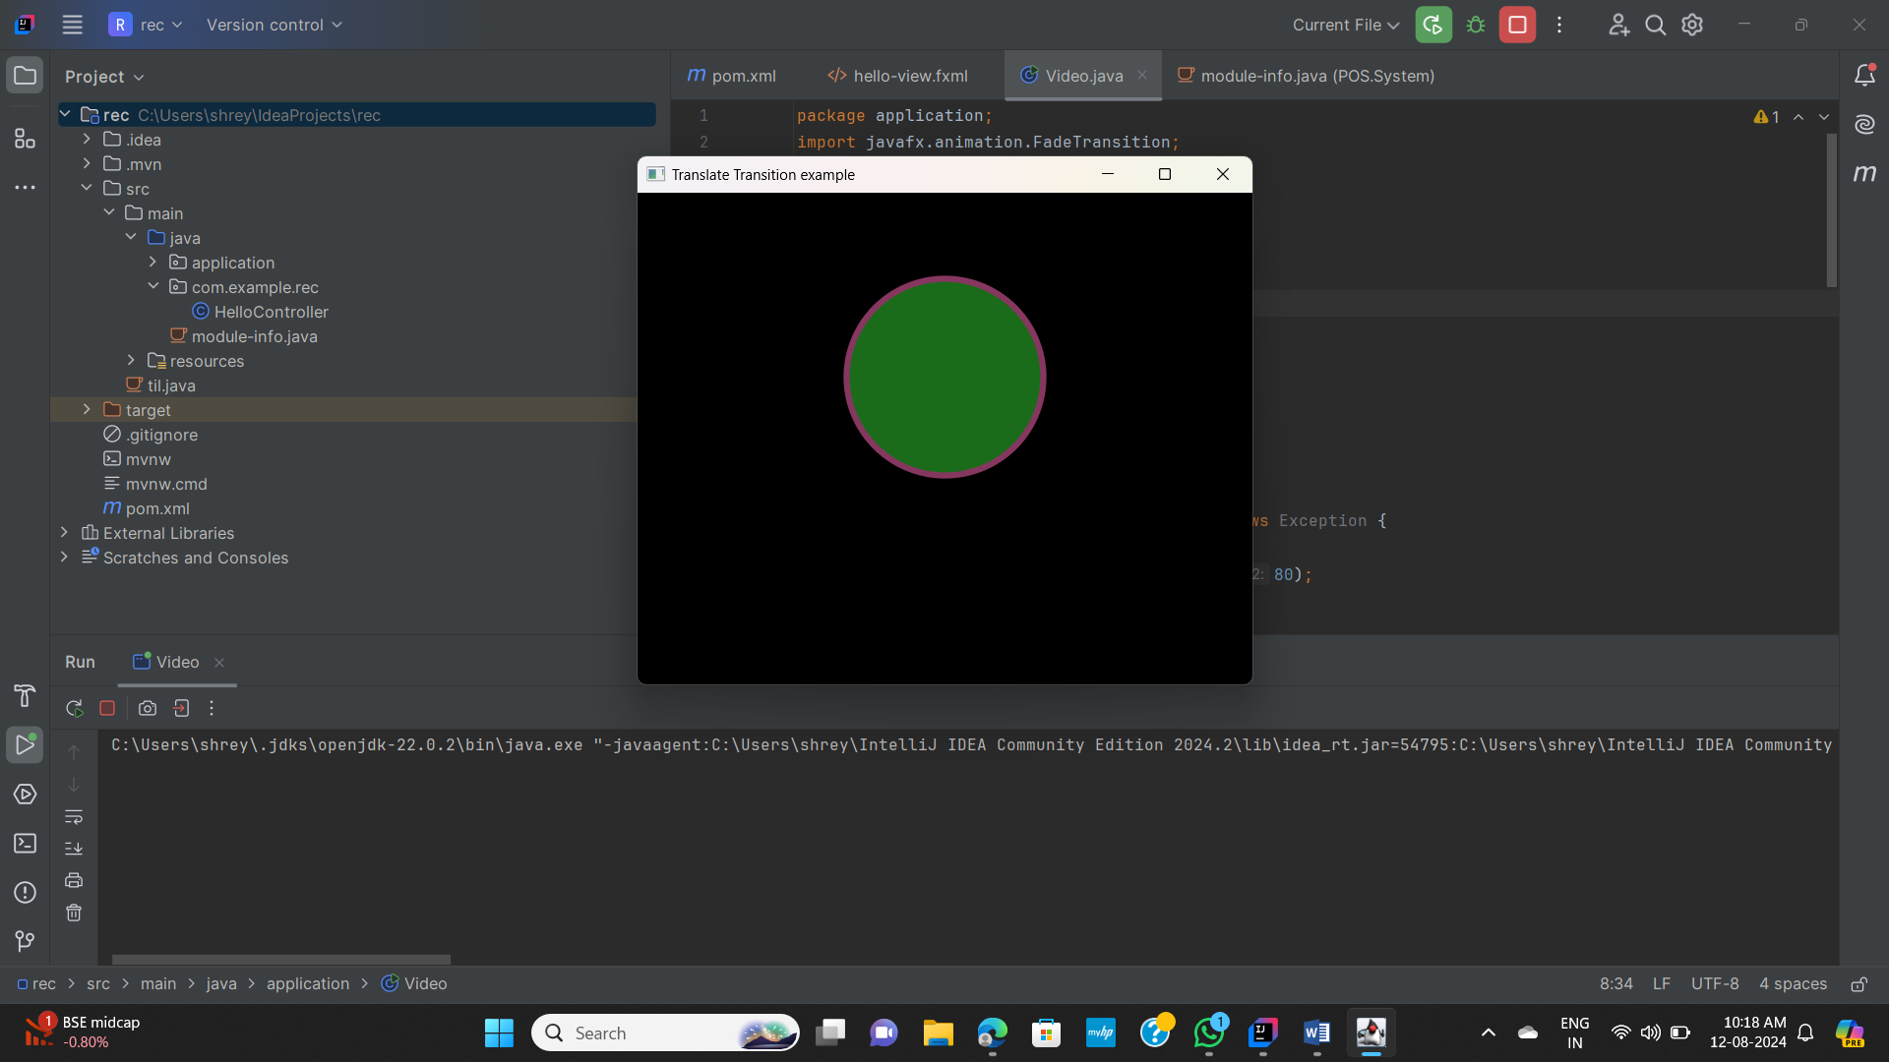

package application;  
import javafx.animation.TranslateTransition;  
import javafx.application.Application;  
  
import javafx.scene.Group;  
import javafx.scene.Scene;  
import javafx.scene.paint.Color;  
import javafx.scene.shape.Circle;  
  
import javafx.stage.Stage;  
import javafx.util.Duration;  
public class Video extends Application{  
  
 @Override  
 public void start(Stage primaryStage) throws Exception {  
  
 Circle c = new Circle(50,100,50);  
 c.setFill(Color.*LIMEGREEN*);  
 c.setStroke(Color.*HOTPINK*);  
 c.setStrokeWidth(5);  
  
  
 TranslateTransition t = new TranslateTransition();  
  
  
 t.setByX(400);  
  
  
  
  
  
 t.setCycleCount(500);  
  
  
 t.setDuration(Duration.*millis*(1000));  
  
  
 t.setAutoReverse(true);  
  
  
 t.setNode(c);  
  
  
 t.play();  
  
  
 Group root = new Group();  
 root.getChildren().add(c);  
 Scene scene = new Scene(root,500,200,Color.*BLACK*);  
 primaryStage.setScene(scene);  
 primaryStage.setTitle("Translate Transition example");  
 primaryStage.show();  
  
 }  
 public static void main(String[] args) {  
 *launch*(args);  
 }  
  
}

